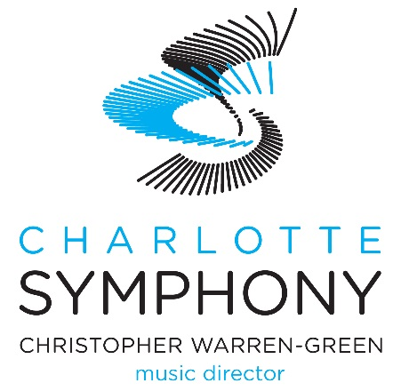

Brand Guidelines for Community Performances

Contact

For media inquiries or questions relating to Charlotte Symphony communications and public relations, please contact Nicole Glaza, Digital Marketing Manager, at nglaza@charlottesymphony.org.

Logo/Copy Usage for Promotional Materials
Please use the included Charlotte Symphony logo on all printed and/or digital promotional materials. Presenter should be clearly indicated, i.e: “The City of Kannapolis welcomes the Charlotte Symphony.”

Conductor Information
Upon first reference, Conductor [Full Name] should be listed as such. Upon second reference, Maestro [Last Name] will suffice. For any questions about titles or pronunciation, please contact Nicole Glaza.

Images
For a high-resolution image gallery, please visit charlottesymphony.org. Please use appropriate photo credits when indicated.

Photography/Video Capture
Due to the Charlotte Symphony musician contractual agreement, no flash photography, video or audio capture is permitted at runout performances without prior approval. Still photography is permitted. An announcement should precede the performance.

Social Media
The Charlotte Symphony encourages engagement via social media. We can be found on Facebook, Instagram, Twitter, and YouTube as cltsymphony. #cltsymphony

For social media events and posts, presenter should be indicated as such, i.e. “The City of Kannapolis presents the Charlotte Symphony.” Please do not use the Charlotte Symphony logo as lead presenter.

About the Charlotte Symphony

Founded in 1932, the Charlotte Symphony is a longstanding nonprofit organization committed to connecting and strengthening our community through exceptional musical experiences. Led by internationally renowned Music Director Christopher Warren-Green, the Symphony upholds the highest artistic integrity and takes bold steps to engage the community through music that enriches the human spirit. We employ professional full-time orchestra musicians, support two youth orchestras and a volunteer chorus, and offer significant educational programming aimed at improving underserved sections of our community. The Charlotte Symphony is integral to the Charlotte area, serving its community through music that connects and inspires. charlottesymphony.org

